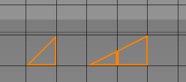
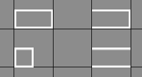
Metatiles that aren’t yet implemented:
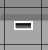
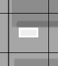
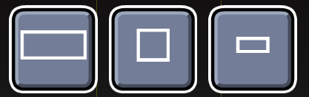

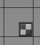
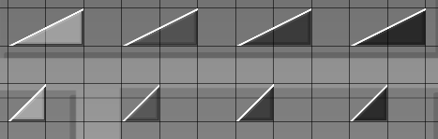

Slope 3dl and 3dfill Other types of 3dl and 3dfill(might not fit)

Sprites that aren’t yet implemented:

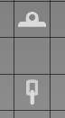


Metatiles that are missing alt color schemes:


(these two require more tileset space bc default is P2)

special attention to:
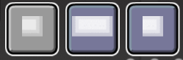

color channels
Default = FFFFFF (255, 255, 255)
Col1 = FF96FF (255, 150, 255)
Col2 = FFFF96 (255, 255, 150)
Col3 = 96FFFF (150, 255, 255)
Col4 = 96FF96 (150, 255, 150)
P1 = AF96FF (175, 150, 255)
P2 = FF9696 (255, 150, 150)
LBG = 4BAFFF (75, 175, 255)

OBJ = FFFFFF (255, 255, 255)
3DL = FFFF00 (255, 255, 0) – prob will not be added

special attention to: those are not important


